MULTIMEDIA PROJECT REPORT

Deadline: Thursday April 16th 2015 5pm

PROJECT TEAM
Student No | First Name | Surname
X14499662 | Muhammad asad | Malik

** Insert Project Name Here **

Master Sports

- OVERVIEW

Motivation for the Project

** Here, you should include the project proposal which was previously submitted, with any changes / amendments needed. **

TARGET CUSTOMER & PROBLEM SOLVING
The target customer for my Product will children, teenager, and adults it appeals to them or who ever want to learn about sports. The website is going to be full of videos and lessons for different types of sports e.g. football, cricket, rugby, and many more. The basic goal of this site is to get more young people to get involved with sports.
DIFFERENTIATION AND BRANDING PLAN
Branding is key when trying to sell a product. My aiming to sell our product to parents of young children. The best way of doing this is to have a colourful and attractive to the eye covers for both our books and our CD’s. They have to look both fun but also educational. My aim to sell our books and CD’s in bookshops, supermarkets and also in our online shop.
My product is different because it shows children sport through animation. Children at the age we’re aiming for (3-8 year olds) are only finding out that sport exists and that it is vital. The best way to teach kids that age is through what they enjoy the most – cartoons.
CUSTOMER ASSESMENT
My main customer would be parents of children who want their young ones to have a pastime. As video games have become more and more common, and the ‘gamers’ have become younger and younger, children have become more house bound each year. My hope that through our product being interesting and helpful it would make the children leave the house and maybe try throwing a ball like the stick figure on their screen.
The beauty of my product is that it’s not limited to a country or even an area. As there aren’t that many written instructions to go along with the short clip, kids from any cultural background can get the gist.

FUNCTIONAL REQUIREMENTS AND TIMELINE
As my project has to teach children, teenager, adult and others about sport, my intend to make plenty of short and simple .SWF files using Animation and animatron. I also try to use plenty of Fireworks throughout the whole website for banners, the logo and general image adjustments and I try to use other tool if I have time left.
The purpose to have my website up and fully functional by the launch of the product.

STORYBOARD / WIREFRAME

** Include storyboard and/or wireframe for your concept here, including descriptions of the user interface. **
Wireframe Homepage
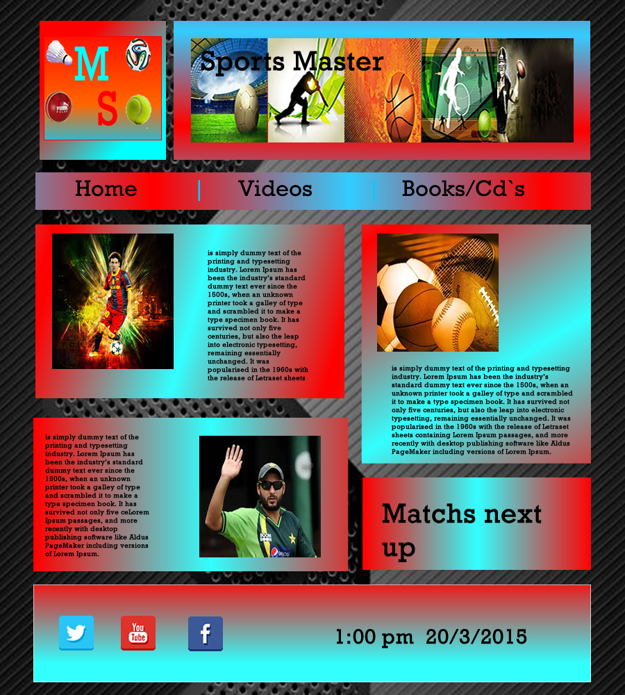

Wireframe of video page

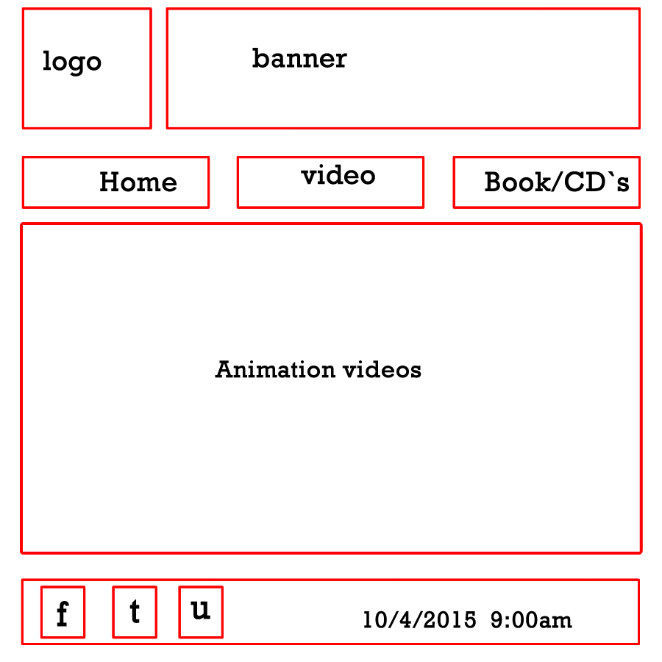

Wireframe of Books/Cd`s page
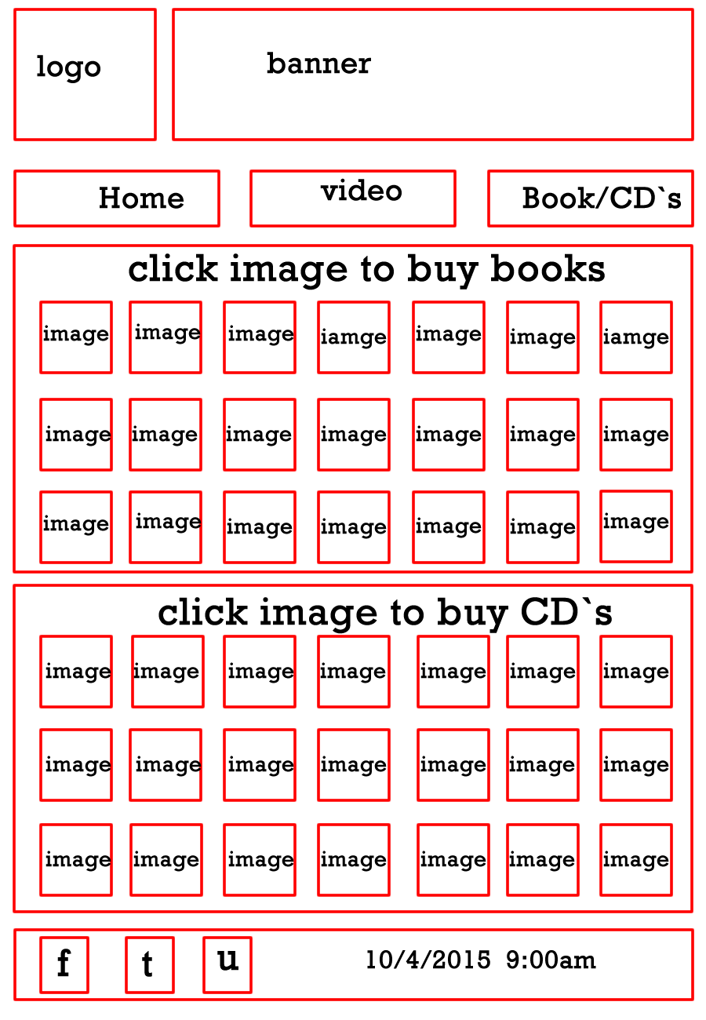

- PRODUCTION LOG

** This section should outline what your project concept is and how you went about developing it. This should include development details, any technical details, such as errors or development issues. **

Adobe Fireworks Elements

** Details of Fireworks/image development here **
I developed my website log, images, button and wireframe on the firework.

Adobe Flash Elements

** Details of Flash/animation development here **
I did one banner in flash and other in animatron

Online / Social Media Elements

** Details of Online / Social Media development here **
I made new Facebook account and made a page for Master Sports
I made new twitter account and made page for Master Sports
On the YouTube I made new channel for Master Sports
Then I link all of them to my website. The loges and images I designed in firework.

Responsive Website Elements

** Details of Responsive Website development here **
- For the responsive website there was three sections computer, phone and tablet screen size. That how I made responsive website

Other Digital Elements

** Details of Other Digital elements development here **
- Animatron is use for my video and banners.
- Have you tube video
- I have use blander animation

- PROJECT TEAM

** How did the project team break up the tasks required?
Who did what tasks?
Muhammad Malik did everything.

Did everyone evenly participate?
NO

Were there any team issues?
Yes the gay was spouse to work with me he never come in so I did all the project.
Etc. **

CONCLUSION

** AFTER COMPLETION, looking back, how did the project go?
Did you achieve what you set out to do?
Are you happy with the results?
Is there anything you might change if you had more time?
Etc. **
Overall I am happy with project, I achieve what set out to do. The website is finish as I have planned. I enjoyed working on this projects, I learned a lot about multimedia tool such as firework, flash, animaton, blander.

